**IN LAB TASK**

EBAD ALI  
24k-0882

#include <iostream>

#include <string.h>

using namespace std;

void registerPeople(char eventA[5][30], char eventB[5][30]) {

cout << "Please enter names for Event A:\n";

for (int i = 0; i < 5; ++i) {

cout << "Participant " << (i + 1) << ": ";

cin >> eventA[i];

}

cout << "\nPlease enter names for Event B:\n";

for (int i = 0; i < 5; ++i) {

cout << "Participant " << (i + 1) << ": ";

cin >> eventB[i];

}

}

bool isRegistered(char eventA[5][30], char eventB[5][30], char* name) {

for (int i = 0; i < 5; ++i) {

if (strcmp(eventA[i], name) == 0 || strcmp(eventB[i], name) == 0) {

return true;

}

}

return false;

}

int calculateTotalMoney() {

return 5 * 10 * 2;

}

void printNamesBackwards(char event[5][30], char* eventLabel) {

cout << "\nPeople in " << eventLabel << " listed in reverse order:\n";

for (int i = 4; i >= 0; --i) {

cout << event[i] << endl;

}

}

void showGraph(int countA, int countB) {

cout << "\nPopularity of Events:\n";

cout << "Event A: ";

for (int i = 0; i < countA; ++i) {

cout << "#";

}

cout << " (" << countA << " people)\n";

cout << "Event B: ";

for (int i = 0; i < countB; ++i) {

cout << "#";

}

cout << " (" << countB << " people)\n";

}

int main() {

char eventA[5][30];

char eventB[5][30];

registerPeople(eventA, eventB);

char checkName[30];

cout << "\nEnter a name to check if they are registered: ";

cin >> checkName;

if (isRegistered(eventA, eventB, checkName)) {

cout << checkName << " is signed up for either Event A or Event B.\n";

} else {

cout << checkName << " is not signed up for any event.\n";

}

int totalMoney = calculateTotalMoney();

cout << "\nTotal money raised: $" << totalMoney << endl;

printNamesBackwards(eventA, "Event A");

printNamesBackwards(eventB, "Event B");

showGraph(5, 5);

return 0;

}

**OUTPUTS**

**TASK 1:**

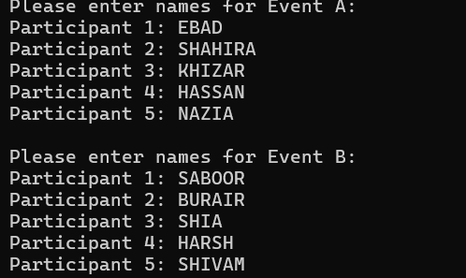

TASK 2:  


TASK 3:



TASK 4:  
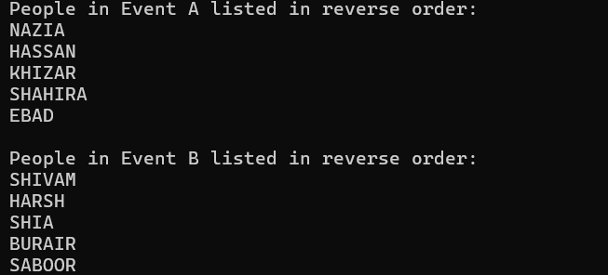

TASK 5:

